**CS 131C# - Beginner**

**HOP03 – Numeric Operators and Routines**

12/31/2019 Developed by Kim Nguyen

Center for Information Assurance (CIAE) @City University of Seattle (CityU)

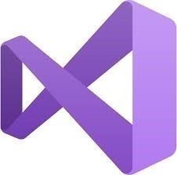

**Before You Start**

* Version numbers may not match with the most current version at the time of writing. If given the option to choose between stable release (long-term support) or most recent, please choose the stable release rather than beta-testing version.
* This tutorial targets Windows users and MacOS users.
* There might be subtle discrepancies along the steps. Please use your best judgement while going through this cookbook style tutorial to complete each step.
* For your working directory, use your course number. This tutorial may use a different course number as an example.
* The directory path shown in screenshots may be different from yours.
* If you are not sure what to do or confused with any steps:
  1. Consult the resources listed below.
  2. If you cannot solve the problem after a few tries, ask a TA for help.

**Learning Outcomes**

Students will be able to:

* Use numeric operators do solve simple math operations
* Comfortable at commenting and explaining code
* Understand incrementation and decrementation
* Revise for loops.

**Resources**

* C# Tutorials | W3Schools.com- <https://www.w3schools.com/cs/default.asp>
* C# Tutorials | tutorials.com- [https://www.tutorialspoint.com/csharp/](https://www.tutorialspoint.com/csharp/csharp_strings.htm)

**Create a project**

1. Open Visual Studio.
2. File > New > Project
3. Select Console App (.NET Core), click Next
4. Type “NumericOperators” in the Project name and save it in the following locations:

**If you are an online student:**

Save it here > CS131-Winter-2020\**ON**\FirstnameLastname/Module3/Operators-Routines/NumericOperators

**If you are an onsite student:**

Save it here > CS131-Winter-2020\**IN**\FirstnameLastname/Module3/ Operators-Routines/ NumericOperators

**Part I. Numeric Operators**

You should be in CS131-Winter-2020\**ON**\FirstnameLastname/Module3/ Operators-Routines/ NumericOperators

1) Type the code in the following screen shot into your Program.cs:

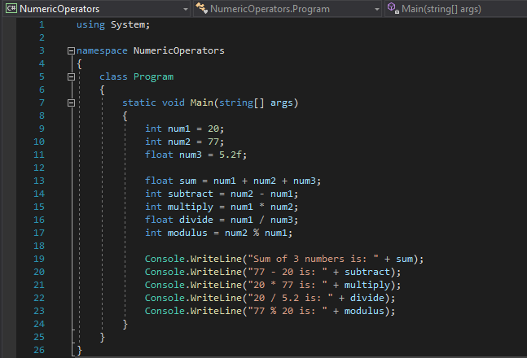

2) Run your program, you should see:

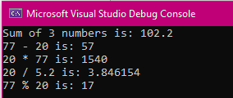

**Challenge 1: Explain the code above by commenting the code**

**Part II: Routines**

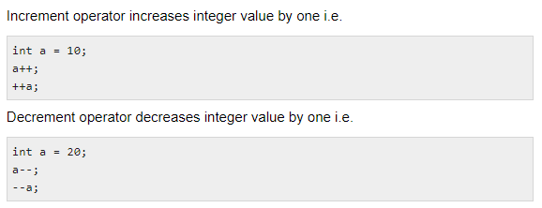

Let’s go back to the for loop we have learned in Week 2’s HOP:

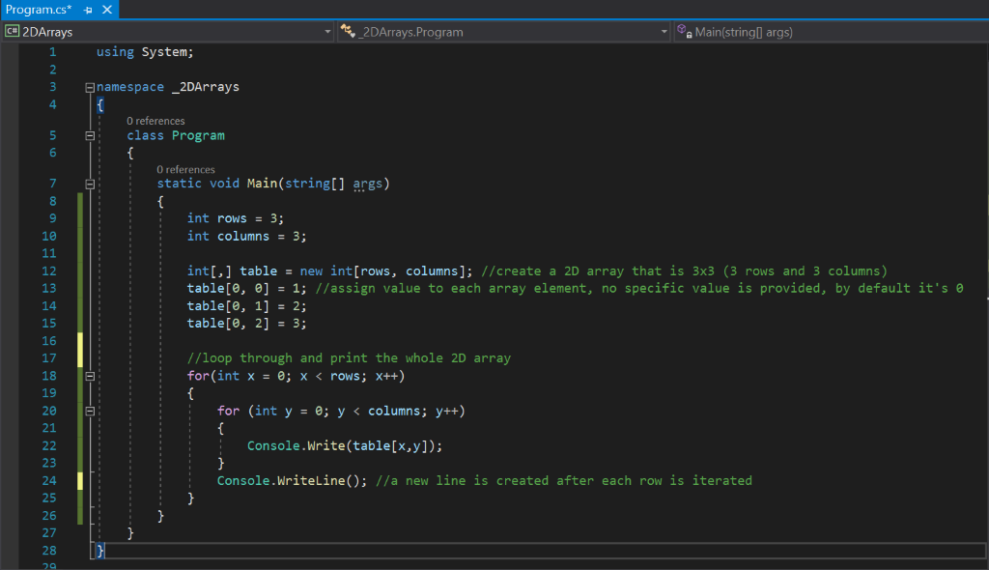

Interger x and y start to be counted from 0, and incremented by each time the for loop is read. Until x is equal to rows (3) and y is equal to columns (3), the for loop is completed. Now, let’s try to use a for loop again to understand it better.

**Create a project**

File > New > Project

Select Console App (.NET Core), click Next

Type “Increment-Decrement” in the Project name and save it in the following locations:

CS131-Winter-2020\**ON**\FirstnameLastname/Module3/Operators-Routines/

You should be in CS131-Winter-2020\**ON**\FirstnameLastname/Module3/ Operators-Routines/ Routines/Increment-Decrement

1) Type the following code in your Program.cs

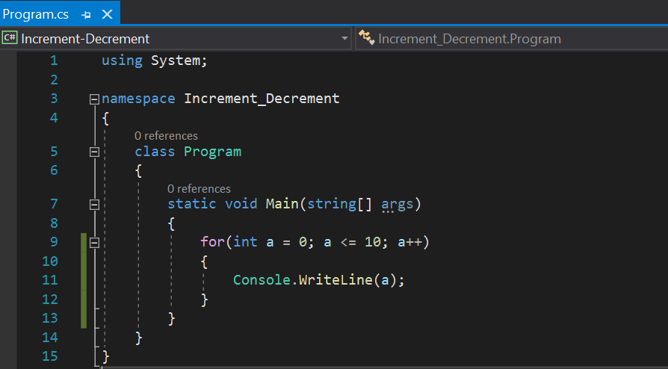

2) Run the program, you should see:

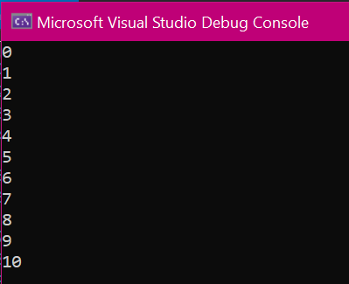

**Challenge 2: Explain the code above by commenting the code.**

**Challenge 3: Use a for loop to print out 15 to 1. Expected result:**

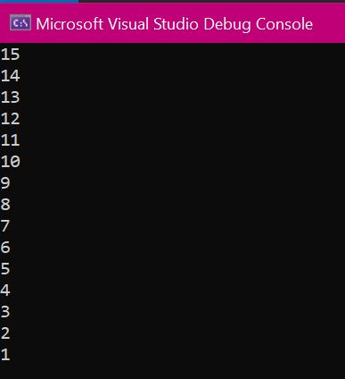

**Push your work to GitHub**

**Commit changes**

1. Click on the **Home** button > **Changes**
2. Type commit message
3. Select **Commit All and Push**

**Create a pull request**

1. Go to your fork page on GitHub website
2. Near the top left side, change the active branch to your new branch
3. Click on the "New Pull Request" button next to the branch name.